**IS for Health Informatics application: Digital dentistry Application.**

A graduation project report submission

In partial fulfillment of the requirements for the award of the degree

Bachelor of Science

**Submitted by:**

Ahmed Gamal Mahmoud 89632

Yousef Mohamed Mahmoud 89474

Yousef Mohamed Ibrahim 89503

Ammar Yasser Ammar Mohamed 89650

**Under the supervision of:**

Dr. Riem M. Hamdi

T.A. Shereen Yosef

T.A. Mohamed Omar

Department of computer science - CS

Misr University for Science and Technology - MUST

College of Computers and Artificial Intelligence Technology – CAIT

June 2023

**Acknowledgment**

We would like to express our deep gratitude to God for granting us the knowledge and abilities necessary to undertake this project. We take this opportunity to extend our thanks to all those who have supported us throughout this endeavor. The success and outcome of this project would not have been possible without the invaluable guidance and assistance provided by numerous individuals, and we consider ourselves extremely fortunate to have had their unwavering support.

Furthermore, we would like to express our special thanks of gratitude to Dr. Riem Hamdi and Dr. Eman Fouad, who gave us a golden opportunity to work on this wonderful project. We came to know so many new things that would help us a lot in our career and we are highly indebt to Dr. Riem for her guidance and constant supervision, as well as providing us with the necessary information regarding the project and for her support during the process of completing the project.

Also special thanks to TA Shereen Yosef and Mohamed Omar for their encouragement, support, and guidance throughout the whole process, by keeping us in tune and providing the necessary information that made us complete the project.

Last and not least, special thanks to the faculty of Information Technology and faculty of dentistry, MUST University for permitting us to use all required equipment and materials to complete our project.

DECLARATION

I hereby certify that this work, which I now submit for assessment on the program of study leading to the award of Bachelor of Science in *Computer Science* is entirely my own work, and that I have exercised reasonable care to ensure that the work is original, and does not to the best of my knowledge breach any law of copyright, and has not been taken from the work of others and to the extent that such work has been cited and acknowledged within the references section of this report.

**Signed:** _____________________________

**Registration No.:** ___________

**Date:**

**ABSTRACT**

Mistakes are an inherent part of being human, and their consequences can vary depending on the situation. Misdiagnosed cases are common in dentistry or medicine in general, due to human error. To address this issue, we went on a mission to assist doctors in identifying horizontal root-fractured teeth by leveraging the power of artificial intelligence (AI). Root fractures pose a particular challenge as they typically require X-rays and a doctor's expertise for accurate diagnosis, yet doctors, being human themselves, are susceptible to errors. This project focuses on harnessing artificial intelligence to enhance doctors' diagnostic capabilities for root fractures. By utilizing an application, dentists can analyze patients' tooth X-rays, ensuring a more reliable and precise diagnosis. Moreover, patients themselves can use the app to seek a second opinion, to confirm the accuracy of their initial diagnosis. By integrating AI into dental practice, we aim to eliminate or at least minimize mistakes This project shows the potential of AI as a valuable tool in healthcare, offering enhanced diagnostic accuracy and empowering patients to actively participate in their own healthcare decisions.

# TABLE OF CONTENTS

List of figures………………………………………………………………………………1

List of figures………………………………………………………………………………4

List of tables………………………………………………………………………………..5

List of acronyms/abbreviations…………………………………………………………...6

List of utilized standards……………………………………………………………...……7

List of realistic constraints…………………………………………………………………8

Chapter 1: introduction…………………………………………………………………….10

1.1 overview……………………………………………………………………………….12

1.1.1 Artificial inelegance…………………………………………………………………12

1.1.2 causes of cracked teeth……………………………………………………………...13

1.2 problem definition…………………………………………………………………….17

1.2.1 What is a tooth fracture?............................................................................................17

1.2.2 What components of a tooth can fracture?................................................................17

1.2.3 What causes tooth fractures?.....................................................................................17

1.2.4 Which teeth are most likely to fracture?...................................................................18

1.2.5 What are the symptoms of cracked tooth syndrome?...............................................18

1.2.6 What are the types of tooth fractures?......................................................................18

1.3 objectives…………………………………………………………………………….19

1.3.1 Helping doctors diagnose cracked teeth………………………………………...…19

1.3.2 Save time and effort………………………………………………………………19

1.3.3 Fewer errors………………………………………………………………………19

1.3.4 help patients………………………………………………………………………19

1.4 Functional requirements & non-functional requirements…………………………..19

1.4.1 Functional requirements…………………………………………………………..19

1.4.2 Non-functional requirements…………………………………………………..…20

1.5 System Requirements……………………………………………………………….20

1.5.1 Software Requirements……………………………………………………………20

1.5.2 Hardware Requirements………………………………………………………………20

1.6 Expected outcomes………………………………………………………………………21

1.7 Conclusion……………………………………………………………………………….21

Chapter 2 Related work…………………………………………………………………….23

2.1 Overview……………………………………………………………………………….1

2.1.1 History………………………………………………………………………………..1

2.2 Literal Review…………………………………………………………………………..3

2.2.1 History and Application of artificial neural networks in Dentistry……………………3

2.2.1.1 Overview……………………………………………………………………………3

2.2.1.2 Methodology………………………………………………………………………..3

2.2.1.3 Advantages………………………………………………………………………….3

2.2.1.4 Disadvantages……………………………………………………………………….3

2.2.2 Evaluation of an artificial intelligence system for detecting vertical root fracture on panoramic radiography…………………………………………………………………………………………………….3

2.2.2.1 Overview……………………………………………………………………………4

2.2.2.2 Methodology………………………………………………………………………..4

2.2.2.3 Advantages…………………………………………………………………………6

2.2.2.4 Disadvantages………………………………………………………………………6

2.2.3 Artificial Intelligence in Dentistry: Past, Present, and Future………………………..6

2.2.3.1 Overview……………………………………………………………………………7

2.2.3.2 Methodology……………………………………………………………………….7

2.2.3.3 Advantages…………………………………………………………………………7

2.2.3.4 Disadvantages………………………………………………………………………7

Chapter 3 System Analysis&Design……………………………………………………….33

3.1.0 System Analysis………………………………………………………………………1

3.1.1 System architecture…………………………………………………………………...1

3.1.2 Use case diagram……………………………………………………………………….2

3.1.3 Activity Diagram……………………………………………………………………….3

3.2.0 Methodologies…………………………………………………………………………16

3.3.0 Algorithms……………………………………………………………………………..17

Chapter 4 Proposed System………………………………………………………………….54

4.1 Overview…………………………………………………………………………………..1

4.2 Introduction………………………………………………………………………………..1

4.3 System Methodology………...……………………………………………………………1

4.4 Algorithms used…………………………………………………………………………...1

4.5 Implemented System Functions..…………………………………………………………2

4.5.1 Libraries Used…………………………………………………………………………..2

4.5.2Preprocessing the data………………………………………………………………….2

4.5.3 Building the model……………………………………………………………………..3

4.5.4 Model Summary………………………………………………………………………..3

4.6 Time plan…………………………………………………………………………………4

Chapter 5 Results&Discussion………………………………………………………………61

5.0 Results & discussion:…………………………………………………………………….1

5.1Expected results:…………………………………………………………………………1

5.2Actual results:……………………………………………………………………………1

5.3 Functional evaluation:……………………………………………………………………1

5.4 Discussion on business value:……………………………………………………………1

5.5Environment impact:……………………………………………………………………..1

5.6 Cost:………………………………………………………………………………………2

5.7 Ethics:…………………………………………………………………………………….2

5.8 Project Evaluation:………………………………………………………………………..2

# LIST OF FIGURES

Fig. 1.1: the difference between AI, ML, DL………………………………………………10

Fig.1.2: self-driving car………………………………………………………………………11

Fig. 1.3: AI in the financial industry…………………………………………………………11

Fig. 1.4: Siri virtual assistant…………………………………………………………………12

Fig. 1.5: AI takes over human jobs…………………………………………………………..12

Fig. 1.6: reactive AI playing chess…………………………………………………………...13

Fig. 1.7: theory-of-mind-AI chatbot………………………………………………………….13

Fig. 1.8: types of cracked teeth……………………………………………………………….14

Fig. 2.1: man exercising………………………………………………………………………3

Fig. 2.2: Daejeon Dental Hospital…………………………………………………………….4

Fig. 2.3: Fractured Tooth X-Ray………………………………………………………...……5

Fig. 2.4: X-Ray of the teeth……………………………………………………………………………7

Fig 3.0.0 How artificial neural network look………………………………………………..16

Fig 3.0.1 CNN layers………………………………………………………………………..17

Fig 4.0.0 Libraries used………………………………………………………………………2

Fig 4.0.1 Preprocessing of the data…………………………………………………………..2

Fig 4.0.2 Building The Model……………………………………………………………….3

Fig 4.0.3 The Summary of the Model……………………………………………………….3

Fig 4.0.4 The Time Plan of the Application…………………………………………………4

**LIST OF TABLES**

Table 1-1: List of headings and their formatting. ..........................................................................5

**LIST OF ACRONYMS/ABBREVIATIONS**

*C H A P T E R 1:*

***INTRODUCTION***

* 1. **Overview**

**1.1.1 Artificial inelegance**

When people hear the term AI, they usually think of robots. That’s because a lot of movies and novels and stories make people think that AI is about robots only, but AI is about robots and many more applications.

Artificial intelligence (AI) is a simulation of human intelligence in machine programming to make decisions or take actions. Artificial intelligence today is a powerful tool to aid humans in all fields. It can be used in industry, education, medicine, agriculture, finance…etc. we could train an AI model and get a shocking result, it can even surpass humans with the right guidance in certain fields. The ideal characteristic of AI is its ability to take actions that can achieve a specific goal.

Machine Learning (ML), which is a subset of artificial intelligence refers to the concept of computer programs that can learn from new data without the help of humans, Deep learning enables this automatic learning through a huge amount of data such as text, images, or video.

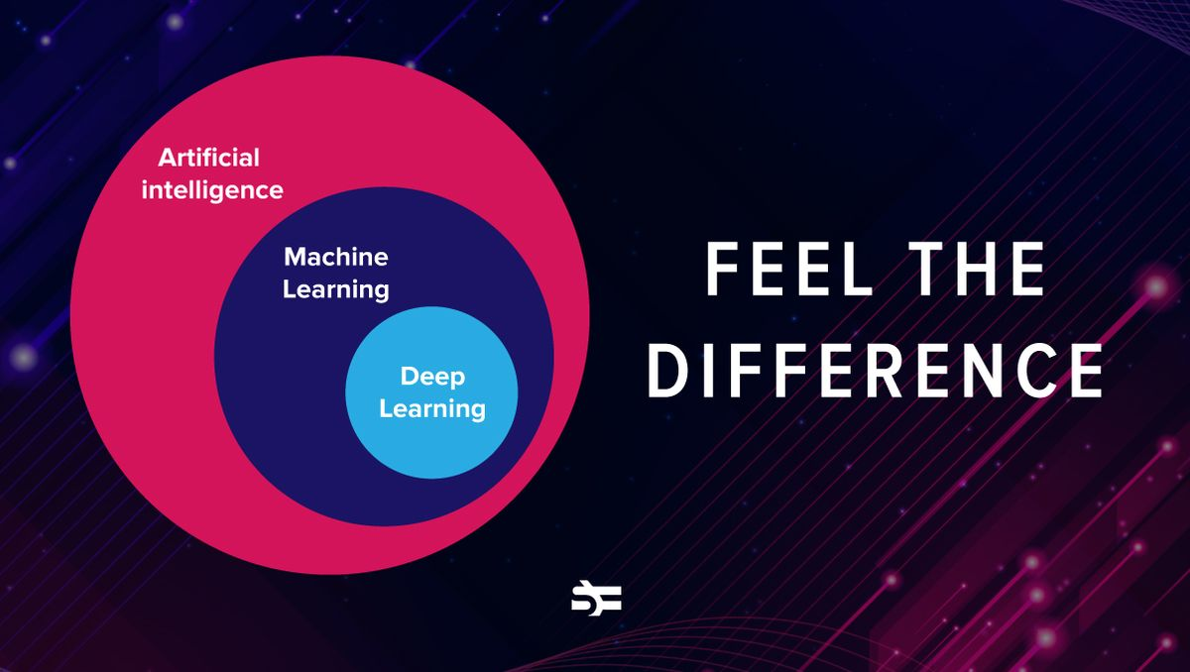

*Fig. 1.1: the difference between AI, ML, DL*

AI is based on the principle that human intelligence can be introduced in a way that machines can mimic it and execute most simple tasks to the most complex ones. The goal of AI is to mimic human cognitive activity. Researchers and developers in the field are making rapid strides in mimicking activities like learning, reasoning, and perception. Some believe that AI may soon be able to develop systems that exceed humans to learn or reason out any subject. Algorithms often play a very important role in the structure of AI, where simple algorithms are used in simple applications, while more complicated ones help frame strong AI. The applications of AI are endless. This technology can be applied in many fields and industries. AI has been tested in the healthcare industry to deliver a range of treatments tailored to specific patients and used to support surgical procedures in the operating room.

Some examples of AI machines include chess-playing computers and self-driving cars. Each of these machines must weigh the consequences of each action, as each action affects revenue. In chess, the result is winning the game. In self-driving cars, the computer system must consider and calculate all external data to act to A person reading a newspaper in a car
avoid collisions.

*Fig.1.2: self-driving car*

AI is also being applied to the financial industry, where it is used to identify and flag banking and financial activity such as unusual use of debit cards and large account deposits all of which help the bank's fraud department. Applications for AI are also being used to streamline and simplify trading. This is done by more easily estimating the supply, demand, and pricing of securities.

*Fig. 1.3: AI in the financial industry*

Artificial intelligence can be divided into two categories: weak and strong. Weak AI embodies systems designed to perform specific tasks. Weak AI systems include video games like the chess example above and personal assistants like Amazon's Alexa and Apple's Siri. Ask the assistant a question, and the assistant will answer.

*Fig. 1.4: Siri virtual assistant*

Strong AI systems are systems that perform human-like tasks. These tend to be more complex and complicated systems. They are programmed to handle situations where problems need to be resolved without human intervention. Such systems are found in applications such as self-driving cars and hospital operating rooms.

Another contentious difficulty many humans have with AI is how it could influence human employment. With many industries seeking to automate jobs, there's a conception that humans might be driven out of the workforce. Self-riding cars may also eliminate the purpose of taxis and cars.

*Fig. 1.5: AI takes over human jobs*

Artificial intelligence can be categorized into four types.

• **Reactive AI:** uses algorithms to optimize outputs based on different inputs. For example, a chess-playing AI is a reactive system that optimizes the best strategy to win the game. Reactive AI tends to be fairly static and unable to learn and adapt to new situations. So given the same input, it will produce the same output.

*Fig. 1.6: reactive AI playing chess*

• **limited memory AI:** can adapt to past experiences and update themselves based on new observations and data. Often the number of updates is limited (hence the name) and the length of storage is relatively short. For example, self-driving cars can “read the road”, adapt to new situations, and even “learn” from past experiences.

• **Theory-of-Mind-AI:** is fully adaptive, with extensive ability to learn and store past experiences. These types of AI include advanced chatbots that can pass the Turing test and trick you into believing your AI is human. This AI is sophisticated and impressive, but not confident.

*Fig. 1.7: theory-of-mind-AI chatbot*

• **Self-aware AI:** is, as the name suggests, sentient and aware of its existence. While still in the realm of science fiction, some experts believe AI will never be conscious or “alive.”

**1.1.2 causes of cracked Teeth**

The incidences of cracks in teeth seem to have increased during the past decade. Dental practitioners need to be aware of cracked tooth syndrome (CTS) to be successful at diagnosing it. Early diagnosis has been linked with successful restorative management and a predictably good prognosis. A cracked tooth is defined as an incomplete fracture of the dentine in a vital posterior tooth that involves the dentine and occasionally extends into the pulp.

*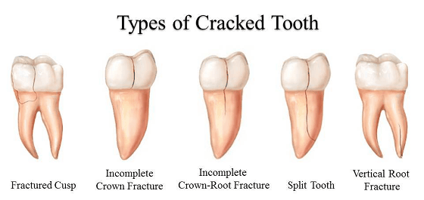fig 1.8 Types of cracked teeth*

The term "cracked tooth syndrome" (CTS) was first introduced by Cameron in 1964. The diagnosis of CTS is often problematic and has been known to challenge even the most experienced dental operators, accountable largely to the fact that the associated symptoms tend to be very variable and at times bizarre. There may be a history of a course of extensive dental treatment involving repeated occlusal adjustments or replacement of restorations, which fail to eliminate symptoms. The patient will give a history of pain on biting on a particular tooth, often occurring with foods that have small, discrete, harder particles in them, for example, bread with hard seeds. Besides pain on biting, the patient will also experience sensitivity to thermal changes, particularly cold. Patients with a previous incidence of CTS can frequently self-diagnose their condition. Occasionally, there is sensitivity to sweets. It is also important to note that there can be instances when the patient may also remain asymptomatic for a long period. Many dentists would have evaluated them without a conclusive diagnosis. Patients who have an existing cracked tooth are likely to have other cracked teeth. Habits that might contribute to cracked teeth are clenching or grinding, chewing ice, pen, hard candy, or other similar objects.

**1.2 problem definition**

**1.2.1 What is a tooth fracture?**

A broken tooth often called a cracked tooth or cracked tooth syndrome (CTS), is a condition in which a tooth is cracked. Cracks can be small and harmless. In some cases, teeth can crack or chip.

Fractured teeth are most common in children and the elderly, but anyone can get a fractured tooth.

**1.2.2 What components of a tooth can fracture?**

Teeth include components:

• The crown is seen above your gums.

• The root lies beneath your gums.

Both the crown and the basis include numerous layers:

• Enamel: Hard white outer surface.

• Dentin: Middle layer of the teeth.

• Pulp: Soft internal tissue that carries blood vessels and nerves.

Tooth fractures can affect a few or all of those layers. Treatment for a cracked tooth relies upon where the fracture takes place and the severity of the fracture.

A damaged tooth may also harm or experience sensitivity, though a few fractures reason no symptoms.

**1.2.3 What causes tooth fractures?**

The most common causes of tooth fractures are:

* **Age:**  many tooth cracks happen at age 50 and older.
* **Biting hard foods:** such as candy, ice, or popcorn kernels.
* **Habits:**such as gum chewing or ice chewing.
* **Large dental fillings or a root canal:** weaken the tooth.
* **teeth grinding (bruxism)**
* **Trauma:** including falls, sports injuries, bike accidents, car accidents, or physical violence.

**1.2.4 Which teeth are most likely to fracture?**

Fractures happen most usually at the upper front teeth and the teeth in the direction of your lower jaw (mandibular molars). Though people generally fracture one tooth, greater extreme harm or trauma may also fracture more than one tooth. People with dental cavities have a higher danger of fracture, even with less extreme trauma.

**1.2.5 What are the symptoms of cracked tooth syndrome?**

Cracked teeth don’t always cause symptoms. When they do, the main symptoms include:

* Pain that comes and goes.
* sensitivity to temperature changes or eating sweet foods.
* Swelling around the tooth.
* toothache when chewing.

**1.2.6 What are the types of tooth fractures?**

Your dentist will classify your fracture as one of the following five categories:

• Cracked Tooth:

The tooth has a vertical crack from the chewing surface to the gum. Cracks may extend to the gum line and roots.

• Craze Lines:

Small thin cracks appear in the enamel on the outside of the tooth. Craze lines do not cause pain.

• Cracked cusps:

Cracks around the filling of the tooth. Broken bumps are usually less painful.

• Split Tooth:

A crack extends from the surface of the tooth to the bottom of the gum. This fracture splits the tooth into two parts.

• Vertical root fractures:

Cracks start under the gum and move toward the occlusal surface of the tooth. A vertical root fracture may not cause symptoms unless the tooth becomes infected.

**1.3 objectives**

**1.3.1 Helping doctors diagnose cracked teeth**

**T**his project aims to build an application that can help doctors diagnose cracked teeth using AI.

**1.3.2 Save time and effort.**

this project can save time and effort for the doctors in their field, doctors don't have to see the X-ray of their patients with their own eyes, they can use the application to scan the X-ray, and the application will save time and effort, and give them the output immediately.

**1.3.3 Fewer errors**

This application can make fewer errors than doctors because it depends on AI and deep learning, so we can give the application a huge amount of data to learn from it if the tooth is cracked and what type of cracked tooth is it, so the application will be more effective than the doctors because they are human beings and they can make errors.

**1.3.4 help patients**

This application will help patients to be diagnosed faster and they won’t wait for a long time for their doctor to diagnose their cracked teeth, so this will make doctors treat their patients faster, and then they can continue their life naturally.

**1.4 Functional requirements & non-functional requirements**

**1.4.1 Functional requirements:**

1. Users can log in to the application.
2. Users can sign up for the application.
3. The app can scan an X-ray to define the type of fractured tooth.
4. The app will store every X-ray the user scanned in the database.

**1.4.2 Non-functional requirements:**

1. Performance
2. Availability
3. Security
4. Usability
5. Maintainability

**1.5 System Requirements**

AI Model

1- Colab Notebooks

2- Tensorflow

3- Dataset of fractured teeth and

Backend

1- ASP.Net core 6

Application

1- Flutter

2- Visual studio code

3- Android Studio

4- Dart

**1.5.2 Hardware Requirements**

-none

**1.6 Expected outcomes.**

At the end of the project, it’s hoped that there’ll be a working mobile application that when the user scans an X-Ray it’ll process the photo and inform him whether he got a fractured tooth or not.

The goal is to eliminate human error in diagnosing CTS or at least we can minimize it as far as we could.

patients are given an easy way to have a second opinion instead of going through the hustle of going to another doctor and so.

**1.7 Conclusion**

Artificial intelligence technology has been widely used in dentistry, according to studies, artificial intelligence can be very useful in dentistry, so artificial intelligence should be seen as a tool to help dentists to perform more useful tasks such as integrating patient information and strengthening professional relationships.

Ensuring artificial intelligence is integrated in a safe and controlled manner is critical to maintaining the ability of people to direct treatment and make informed decisions in dentistry.

There is a huge number of studies have already found a lot of benefits of integrating artificial intelligence technology into dentistry, and artificial intelligence will play an important role in the dental industry in the future.

*C H A P T E R 2:*

***RELATED WORK***

**2.1 Overview**

In this chapter, we’re going to discuss some related work surrounding tooth fractures, starting with a brief history. then we’re going to see how artificial neural networks were used in dentistry before. then how root fractures can be detected with AI and how the future might help dentistry and dentists in general

**2.1.1 History**

A fractured tooth often called a cracked tooth or cracked tooth syndrome (CTS), is when a crack appears in your tooth. The crack can sometimes be small and harmless. Other times, it can cause your tooth to break or split. Tooth fractures are most common in children and older people, although anybody can crack a tooth. If you suspect a broken tooth, see a dentist right away. Chipped and broken teeth cause Our teeth to be really strong, but with the many stresses and strains that they have to endure, they can chip, crack or break. Common causes of these breaks can include Eating something hard, Facial trauma following an accident, Damage from sports, Untreated cavities that can cause a tooth to become brittle and break, Old, large amalgam fillings, where the remaining structure of the natural tooth can become brittle over some time. Broken teeth may not necessarily cause immediate pain. If the break has traveled to the nerve, you might experience occasional discomfort when chewing, for example, or sensitivity to hot and cold. Whether you are in pain or not, all breaks should be investigated by your Portman dentist as soon as possible to check the health and stability of the tooth and to provide necessary treatment to prevent further deterioration or problems. The incidences of cracks in teeth seem to have increased during the past decade. Dental practitioners need to be aware of cracked tooth syndrome (CTS) to be successful at diagnosing CTS. Early diagnosis has been linked with successful restorative management and a predictably good prognosis. The purpose of this article is to highlight factors that contribute to detecting cracked teeth. A cracked tooth is defined as an incomplete fracture of the dentine in a vital posterior tooth that involves the dentine and occasionally extends into the pulp. The term “cracked tooth syndrome” (CTS) was first introduced by Cameron in 1964. The diagnosis of CTS is often problematic and has been known to challenge even the most experienced dental operators, accountable largely to the fact that the associated symptoms tend to be very variable and at times bizarre. This article aims to provide an overview of the diagnosis of CTS. Diagnosing CTS has been a challenge to dental practitioners and is a source of frustration for both the dentist and the patient. Identification can be difficult because the discomfort or pain can mimic that arising from other pathologies, such as sinusitis, temporomandibular joint disorders, headaches, ear pain, or atypical or facial pain. Thus, diagnosis can be time-consuming and represents a clinical challenge. Early diagnosis is paramount as restorative intervention can limit propagation of the fracture, subsequent microleakage, involvement of the pulpal or periodontal tissues, or catastrophic failure of the cusp. The ease of diagnosis varies according to the position and extent of the fracture. Mandibular second molars, followed by mandibular first molars and maxillary premolars are the most commonly affected teeth. The tooth often has an extensive intracolonial restoration. The pain may sometimes occur following dental treatments, such as cementation of an inlay, which may be erroneously diagnosed as interferences or high spots on the new restoration. Recurrent deboning of cemented intracolonial restorations such as inlays may indicate the presence of underlying cracks. When eliciting the history from the patient, certain distinct clues can be obtained. There may be a history of a course of extensive dental treatment involving repeated occlusal adjustments or replacement of restorations, which fail to eliminate symptoms. The patient will give a history of pain on biting on a particular tooth, often occurring with foods that have small, discrete, harder particles in them, for example, bread with hard seeds or muesli. Besides pain on biting, the patient will also experience sensitivity to thermal changes, particularly cold. Patients with a previous incidence of CTS can frequently self-diagnose their condition. Occasionally, there is sensitivity to sweets. It is also important to note that there can be instances when the patient may also remain asymptomatic for a long period. Many dentists would have evaluated them without a conclusive diagnosis. Patients who have an existing cracked tooth are likely to have other cracked teeth. Habits that might contribute to cracked teeth are clenching or grinding, chewing ice, pen, hard candy, or other similar objects. Then, Panoramic radiography is frequently used for screening for various abnormalities of the jaws and their adjacent structures and is recognized as a reliable and convenient technique. However, because of the complexity of the relationships between anatomical structures and the panoramic

image layer, panoramic radiography images may sometimes be difficult to interpret, especially for inexperienced observers, with the result that critical diseases may be overlooked. In this regard, several computer-assisted detection/diagnosis (CAD) systems have been developed for various diseases, including maxillary sinusitis, osteoporosis, and carotid artery calcification. In these systems, image characteristics that are extracted by experienced human observers are input into the CAD system for diagnostic assistance. More recently, deep learning (DL) systems with convolutional neural networks (CNN) have been introduced into the field of oral and maxillofacial diagnostic imaging.

**2.2 Literal Review**

**2.2.1 History and Application of artificial neural networks in Dentistry**

**2.2.1.1 Overview**

The purpose of this research is to try to predict toothache and to explore the relationship between dental pain and daily tooth brushing and their lifestyle.

**2.2.1.2 Methodology**

It was tried and tested by scientists and researchers to prove if there is a relationship between the lifestyle of the people and trying to predict toothache.

They tried to know how many times they eat and how many times they brush their teeth (before or after the meals).

And if they are eating healthy or junk food and if the patient is exercising or not and if he is using a toothbrush or dental floss. [Wook Joo Park, Jun-Beom Park, (September 23, 2019) History and application of artificial neural networks in dentistry, Volume 12].

**2.2.1.3 Advantages**

* It encouraged people to eat healthily and exercise.
* Make people brush their teeth more than once a day.
* And make people stop the bad habits they used to do.

**2.2.1.4 Disadvantages**

* It won’t be accurate enough if there is a one-time change in the day.
* Doesn’t give you fast results.
* 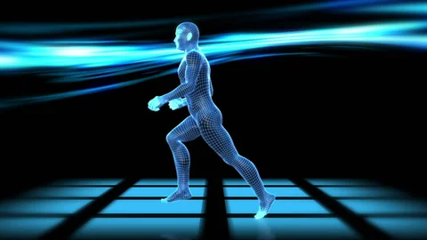Always needs updates about the lifestyle.

Man exercising Fig 2.1

**2.2.2 Evaluation of an artificial intelligence system for detecting vertical root Fractures on panoramic radiography**

**2.2.2.1 Overview**

The purpose of this study was to evaluate the performance of a convolutional neural network (CNN) system for vertical root fracture (VRF) detection on panoramic radiography.

**2.2.2.2 Methodology**

The study design and protocol were reviewed and authorized by the Institutional

Review Board of the Veterans Health Service Medical Center (VHSMC, approval no. BOHUN

2020-03-012-001, 13 April 2020) and Daejeon Dental Hospital, Wonkwang University

(approval No. W2011/002-001, 23 April 2020), and the need for informed or written consent

were waived as part of the study approval. This study was conducted in compliance with

the revised Declaration of Helsinki and followed the STROBE guidelines for the conduct

and reporting of observational studies.

## *Fig. 2.2 Daejeon Dental Hospital*

We retrospectively obtained a dataset from January 2006 to December 2015 in VHSMC

and from April 2007 to December 2019 in WKUDH. A total of 21,398 DIs in 7281 patients

were reviewed through dental electronic records, clinical photos, and dental digital radiographic

images by two participating board-certified periodontists (DWL and JHL) and

one board-certified prosthodontist (SYK). All periapical images were obtained using the

standard paralleling technique, and radiographic images with severe noise, haziness, or

distortion were excluded by the three dental professionals mentioned. Following this, one

periodontist (JHL) manually and multiply segmented the anonymized DICOM format DI

images (panoramic images with a pixel resolution of 2868 _ 1504 and periapical images

with a pixel resolution of 1876 _ 1402), using radiographic image analysis software (INFINITT PACS, INFINITT Healthcare and Osirix X 10.0 64-bit version, Pixmeo SARL), into the region of interest. Finally, 251 intact and 198 fractured DIs were identified and included

as the total dataset in this study. The fractured DIs were classified into three groups, referring

to a previous study that analyzed the pattern of fracture (Type I, horizontal and vertical

fractures limited within and around the crystal module; Type II, vertical fracture beyond

the crystal module; and Type III, horizontal fracture over the crystal module) [20]. However,

the number of type-III fractured DIs was very small (n = 4) in the process of obtaining

## A close-up of a skull Description automatically generated with low confidencedatasets; therefore, only type-I and -II fractured DIs were included in this study.

## *Fig 2.3 Fractured Tooth X-Ray*

Withthe assistance of AI diagnostic models, radiologists are hoping to not only be relieved from reading and reporting on a large number of medical images but also to improve work efficiency and achieve more precise outcomes regarding the final diagnosis of various diseases. Radiographs can aid in evaluating the pulpal and periodontal health of a tooth, but it is rare to see a crack on a radiograph. Radiographs tend to be of limited use as fractures tend to propagate in a mesiodistal direction, parallel to that of the plane of the film. However, they can be useful in detecting more rarely occurring fractures that may run in a buccolingual direction and for excluding other dental pathology. Experienced clinicians using a clinical microscope have reached a consensus that ×16 provides an ideal magnification level for the evaluation of enamel cracks, with a range from ×14 to ×18. The use of the clinical microscope makes possible the treatment of asymptomatic but structurally unsound posterior teeth. Ultrasound is also capable of imaging cracks in simulated tooth structure and could pose an important diagnostic aid in the future. Where direct diagnostic methods prove unsuccessful, indirect diagnostic methods like banding can be used to detect CTS. The use of copper rings, stainless steel orthodontic bands, and acrylic provisional crowns may be placed on the tooth to prevent the separation of the crack during function. Upon review, following a period of 2–4 weeks after the application of the immediate splint, the absence of pain has been described to indicate not only a correct diagnosis but also successful immobilization. Another indirect diagnostic method is an unauthenticated technique which Banerji et al. mentioned in their review on cracked teeth. They recommend placing composite resin over the tooth without etching and bonding. The material is added and wrapped across the external line angles that act as a splint. The patient when asked to bite finds a great reduction in discomfort as the material acts as a splint. [ Motoki Fukuda, Kyoko Inamoto, (September 18, 2019), Evaluation of an artificial intelligence system for detecting vertical root fracture on panoramic radiography(original article), Japanese Society for Oral and Maxillofacial Radiology and Springer Nature Singapore].

**2.2.2.3 Advantages**

* It will encourage people to try it to detect if their teeth have any fractures.
* Can make it easier for doctors to detect if there is a fracture.
* It is going to be cheap.

**2.2.2.4 Disadvantages**

* It is not accurate and efficient since it didn’t get all the fractures.

**2.2.3 Artificial Intelligence in Dentistry: Past, Present, and Future**

**2.2.3.1 Overview**

Vertical root fractures (VRF), a serious consequence that may need root resection or tooth extraction, account for 2% to 5% of crown/root fractures. Radiographs and (CBCT) imaging helps to detect a Vertical Root Fracture, which can be difficult to diagnose. Additionally, a lack of a definitive diagnosis could result in unnecessary surgery or tooth extraction.

**2.2.3.2 Methodology**

It was investigated by using 128 patients who had 135 teeth with clinically possible root fractures. Conventional dental radiography, CBCT, and ultimately surgical investigation were all performed on these individuals. 49 of the 135 teeth had undergone endodontic treatment, compared to 86 that hadn't. Each patient's dental radiographs and CBCT pictures were independently examined by two oral radiologists, who then concluded. The detection of separation of the adjacent root segments on at least two contiguous sections and at least two three-dimensional (3D) planes were defined as the CBCT finding of a root fracture. [Agrawal P, Nikhade P (July 28, 2022) Artificial Intelligence in Dentistry: Past, Present, and Future. Cureus 14(7)].

**2.2.3.3 Advantages**

* It can avoid unnecessary surgery.
* Help dentists identify serious issues that aren’t visible to the naked eye during dental exams.
* Shows a full view of tooth roots and assesses the severity of periodontal disease

**2.2.3.4 Disadvantages**

* A picture containing blur

  Description automatically generatedThe patient still needs a doctor anyway.

*X-ray of the teeth Fig 2.4*

***C H A P T E R 3:***

***SYSTEM ANALYSIS & DESIGN***

* 1. **.0 system analysis**

System Analysis refers to the process of examining a business situation with the intent of improving it through better procedures and methods. It relates to shaping organizations, improving performance, and achieving objectives for profitability and growth. The emphasis is on systems in action, the relationships among subsystems, and their contribution to meeting a common goal.

* + 1. **system architecture**

**3.1.2 use case Diagram**

**Use case description:**

-**login**:

Takes information from the user to log him in after authentication.

-**verify user**:

Makes sure if the user inserted data that are in the database or not.

-**register**:

Is the process to make new accounts for doctors and admins of the clinic.

-**authentication**:

Makes sure if the user inserted registration information right or wrong.

-**upload patient data**:

The process is used to help doctors insert their patient's information and upload their X-ray photos.

-**View patient data**:

The process is used to make doctors view their history in the application and the information of their patients.

**3.1.3 Activity diagram**

**Activity description:**

in the beginning, the user chooses either to log in or to signup to make a new account.

**-Login:**

Takes information from the user to log in.

**-Signup:**

Takes information from the user to make a new account and then directs him to the login page.

**-Right info:**

If the information is right the application directs the user to the next stage, if not the application directs him to the login page.

**-upload x-ray:**

After the user login, he will be directed to a page to insert his patient information and to upload his x-ray to be scanned.

**-scan x-ray:**

after the user uploads the x-ray the ai model will scan it to define where and what type is the fracture.

**-show result:**

After the ai model scans the fractured teeth the user can see the result of the scan of the x-ray.

**Login and registration – sequence diagram – scenario**

1. If the user chooses to log in to the application, the application will check if the information the user inserted is in the database, if yes, the application will direct the user to the home page, if not the application sends an error message.
2. If the user chooses to sign up the application will send a request to the database to decide if the information is valid or invalid, if valid the information will be stored in the database and the application will direct the user to the home page, if invalid the database reject the request and the application send an error message.

**Scanning x-ray – sequence diagram – scenario**

1. When the user uploads an X-ray to the application, the application sends the X-ray to the ai model.
2. The ai model scans the X-ray and then sends the results of the X-ray to the database to store it.
3. The database returns the results of the scanned X-ray to the application.
4. The application displays the results to the user.

**Context diagram description**

As shown in the context diagram three users can use the application.

1. The individual doctor can log in to the application or register if he doesn’t have an account, he can insert the information of his patients and upload an x-ray to the ai model to scan it and receive his patients’ results.
2. The clinic’s doctor is a doctor that works under a clinic or organization that can access his account and his patients’ information, he can use the app like the individual doctor and receive his patients’ results.
3. The admin can log in to his account or register for an account to add the doctors who work in his clinic or his organization, he can access the accounts of his doctors and their patients’ information.

**Data flow diagram Description:**

**Processes:**

1. Signup
2. Login
3. Upload patient data
4. Show result.

**Data store:**

1. Individual doctor info
2. Clinic info
3. Individual doctor x-ray
4. Clinic x-ray

**External entities:**

1. Individual doctor
2. Clinic’s doctor
3. Admin

**Processes description:**

1. signup

|  |  |  |
| --- | --- | --- |
| input | Process description | Output |
| User information(first name-email-password- etc) | Takes information from the user to make a new account from him | Response with valid or invalid information |

1. login

|  |  |  |
| --- | --- | --- |
| input | Process description | Output |
| User information (first name-email-password- etc.) | Authenticate the user by checking inserted information | Response with success or failure |

1. upload patient data

|  |  |  |
| --- | --- | --- |
| input | Process description | Output |
| Patient’s information (name – email – x-ray – etc.) | Allow user to upload patient information and scans x-ray and store it in the database | Stores patient data in the database |

1. show result

|  |  |  |
| --- | --- | --- |
| input | Process description | Output |
| Takes information stored in the database | Return patient information and x-ray result to the user | Return x-ray result |

**Child Diagram Description:**

3.1- upload x-ray

The user can upload the patient’s x-ray so it can send it to the ai model to scan it.

3.2- scan x-ray

In this process, the ai model scans the X-ray and then sends the result to the database so it can be reviewed by the user.

**class diagram Description:**

1. user class: in the user class there are the data that are common in individual doctor class, admin class, and clinic’s doctor class so they can inherit from the user class.
2. Admin class: in the admin class there will be the address and name of the clinic or the organization and it can inherit needed data from the user class.
3. Individual doctor: this class will inherit all data from the user class and there will be an association relationship with the patient class so the doctor can add the patient’s information.
4. Clinic’s doctor: will inherit data from an individual doctor and can also add patient’s information.

**state diagram description:**

1. First, the user will open the application and he will have to choose either to sign up or log in.
2. If the user sign up and inserts the right information, he will be directed to the login page, if he is wrong, he will repeat and signup again.
3. If the user logs in and inserted the right information, he will be directed to the home page, if he is wrong, he will repeat and log in again.
4. On the home page, the user will upload the patient's information and upload his x-ray to be scanned.
5. After uploading the X-ray, the ai model will scan the X-ray to define fractured teeth.
6. In the end, the user can review the X-ray result.

**3.2.0 Methodologies**

The waterfall is our methodology of choice that will be used in SDLC (system development lifecycle). Waterfall methodology is a project management approach that emphasizes a linear progression from the beginning to the end of a project. This methodology, often used by engineers, is front-loaded to rely on careful planning, detailed documentation, and consecutive execution. The Waterfall methodology also known as the Waterfall model is a sequential development process that flows like a waterfall through all phases of a project (analysis, design, development, and testing, for example), with each phase completely wrapping up before the next phase begins. It is said that the Waterfall methodology follows the adage to “measure twice, cut once.”

Waterfall software helps project managers handle the task. As Waterfalls are a relatively complex, phased approach, they require close attention and coordination. Waterfall software can be desktop or cloud based. It helps you to Structure your processes, organize tasks, Set up Gantt charts and schedules, and Monitor project progress.

How the application is supposed to work

The system has 3 choices to log in or sign up. You can sign up as a doctor that has a private clinic, or as a clinic admin, that clinic has many doctors associated with it. the clinic admin can add doctors to the system and Doctors in a public clinic or a certain clinic can sign up directly by mentioning their clinic name. After Signing up, all data will be stored in database tables for doctors and clinics in the backend and the user will be navigated to the Login page.

After logging in with their accounts, Doctors can navigate to the home page, and before scanning, they must register the patients' data like their name, Email, and Phone number. Doctors are only then able to upload the X-Ray photo that the AI model will check if it’s fractured or not.

After uploading the X-Ray photo, the user will be navigated to another page to see the result and then the X-Ray image along with the result will be saved to the database.

Doctors have a history tab where old X-Rays will be stored if they want to find a certain patient x-rat or result or check the patient’s history.

* 1. **Algorithm**

Neural networks, also known as artificial neural networks ANNs are a subset of [machine learning](https://www.ibm.com/eg-en/cloud/learn/machine-learning) and are at the heart of [deep learning](https://www.ibm.com/eg-en/cloud/learn/deep-learning) algorithms. Their name and structure are inspired by the human brain, mimicking the way that biological neurons signal to one another. Artificial neural networks (ANNs) are comprised of node layers, containing an input layer, one or more hidden layers, and an output layer. Each node, or artificial neuron, connects to another and has an associated weight and threshold. If the output of any individual node is above the specified threshold value, that node is activated, sending data to

Fig 3.0.0 How artificial neural network look

the next layer of the network. Otherwise, no data is passed along to the next layer of the network.

Convolutional Neural Networks or CNN consist of three layers: a convolutional layer, a pooling layer, and a fully connected layer. each of which learns to detect the different features of an input image. A [filter](https://www.techtarget.com/whatis/definition/filter) or kernel is applied to each image to produce an output that get s progressively better and more detailed after each layer. In the lower layers, the filters can start as simple features.

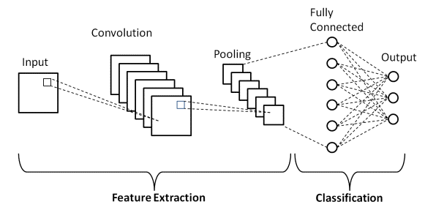fig 3.0.1 cnn layers

CNN is very useful when dealing with images also it can be very accurate at classification and recognition, so it’ll fit best when detecting a root fracture from an x-ray of a tooth.

***C H A P T E R 4: PROPOSED SYSTEM***

**Proposed system**

**4.1 Overview:**

in this chapter we will review the algorithms and the methodology used in the application and the implementation of the code in the application.

Our project uses an AI model to detect fractured teeth with a user-friendly interface in the application so it will be easy to be used by the doctors and fresh graduates.

**4.2 Introduction:**

The proposed system is an application that uses AI model to detect fractured teeth and make it easy for doctors and fresh graduates to diagnose fractured teeth faster by detecting more than one picture in no time.

**4.3 System methodology:**

In this project we used waterfall methodology, it is straightforward and well-defined, with clear requirements laid out from the beginning. This helps us effectively plan our time for the duration of the project. Other advantages of the Waterfall method include faster delivery of the project, efficient review processes, accurate estimation of the total cost of the project and timeline.

In this project we use a mixture of hardware and software. So, the hardware is an android mobile, while the software will be an AI model and mobile application.

**4.4 Algorithms used:**

in this project we used CNN model, Convolutional Neural Networks (CNNs) are extremely successful in areas where large, unstructured data is involved, such as image classification. The main advantage of CNN compared to its predecessors is that it automatically detects the significant features without any human supervision which made it the most used. So we built and trained the model on a lot of fractured and non-fractured teeth dataset to detect fractured teeth x-ray pictures in real life.

**4.5 Implemented system functions:**

In this project we have system functions such as that the user can sign up to the application as a clinic or an individual doctor, then he can upload a picture of an x-ray of tooth to know if it is fractured or non-fractured.

So when the user upload the picture the picture is gone to the AI model (CNN) to be analyzed by the model to tell the user if the tooth is fractured or not fractured.

Here is an implementation of the AI model:

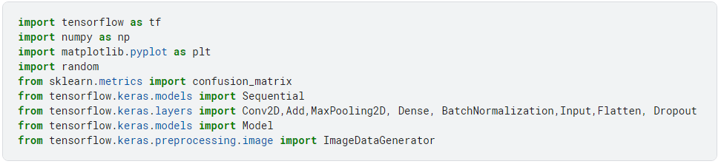 **4.5.1 libraries used:**

Fig 4.0.0 Libraries used

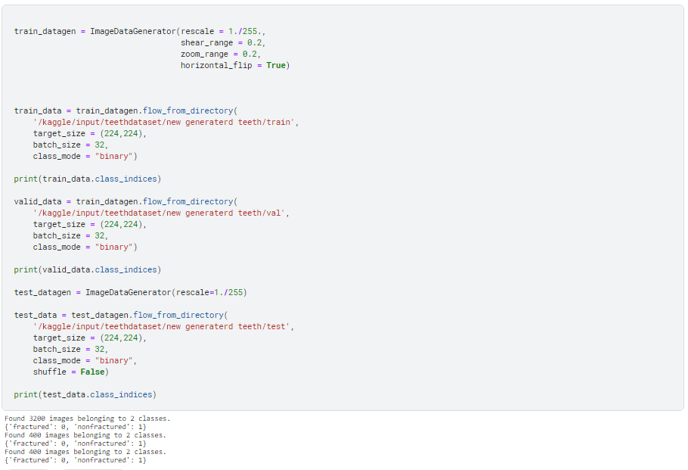**4.5.2 Preprocessing the data:**

Fig4.0.1 Preprocessing the data

**4.5.3Building the model:**

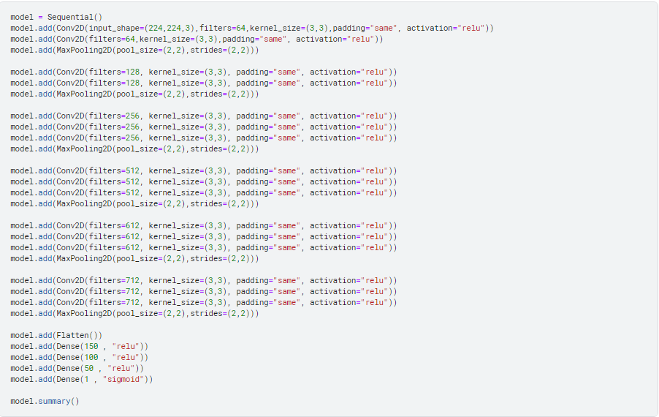

Fig4.0.2 Building the model

**4.5.4 Model summary:**



Fig4.0.3 The Summary of the model

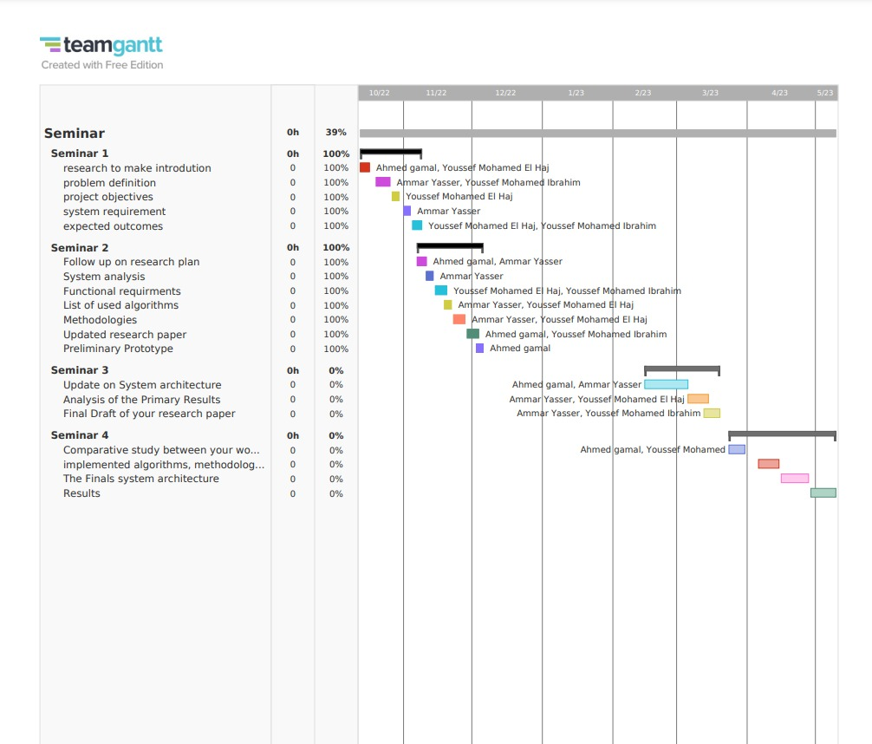**4.6 Time plan:**

Fig 4.0.4 The time plan of the Application

***C H A P T E R 5: RESULTS & DISCUSSION***

**5.0 Results & discussion:**

In this section we will talk about the results of our project and the real outcome of the project. Then we will talk about future plans and what we will do in the future to improve our application.

**5.1 Expected results:**

We expected the user to use the application in an easy way and the application to be used to diagnose fractured teeth. And we expected the AI model to perform good and diagnose all the pictures with an accuracy above 95%.

**5.2 Actual results:**

The results was better than our expectation and the model was able to perform better and it’s accuracy was above 95% and it was able to diagnose all the pictures of x-ray of fractured teeth and non-fractured teeth.

**5.3 Functional evaluation:**

We evaluated and tested the application with many pictures of x-ray of fractured and non-fractured teeth and the AI model was a success and we tested the application and it was easy to use by the users.

**5.4 Discussion on business value:**

The project can help doctors diagnose fractured teeth faster and it can be very beneficial for dental clinics. It can help reduce the time patients spend in the clinic and improve the quality of care.

**5.5 Environment impact:**

The teeth fracture recognition application is not harmful to the environment because it does not use any hazardous materials or chemicals. It is a software application that uses machine learning algorithms to analyze X-rays and diagnose fractures. The application does not produce any waste or pollution and can be used on mobile device.

**5.6 Cost:**

The best part of the project that we saved money in making this project because we only needed pictures of x-ray of fractured and non-fractured teeth so we just spent only 200EGP.

**5.7 Ethics:**

The ethics of this application are important to consider. The application is designed to protect patient privacy and confidentiality. It is also designed to ensure that the diagnosis is accurate and reliable. It is also designed to ensure that the doctors are not overburdened with work and that they have enough time to provide quality care to their patients.

**5.8 Project evaluation:**

In this section we will talk about the project interface and the functionality of it:

First of all the first page that the user will see is the login where he can enter his email and password but if he doesn’t have an account he can click sign up and will enter all his information (email, name, password) then he will click if he is a clinic or an individual the register.

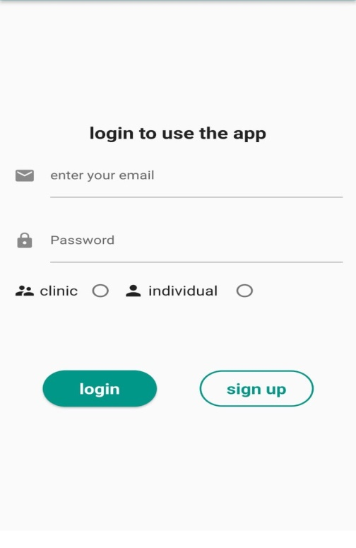 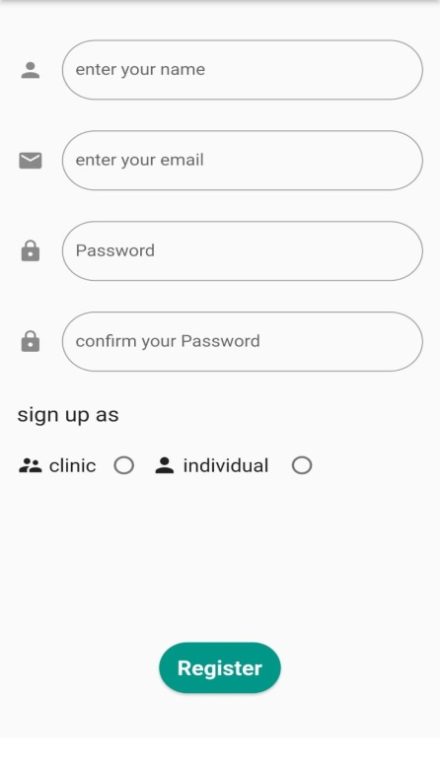

After The login or Sign-up process, the user will see a page that tells him to run a new scan or to view the history of his scans.

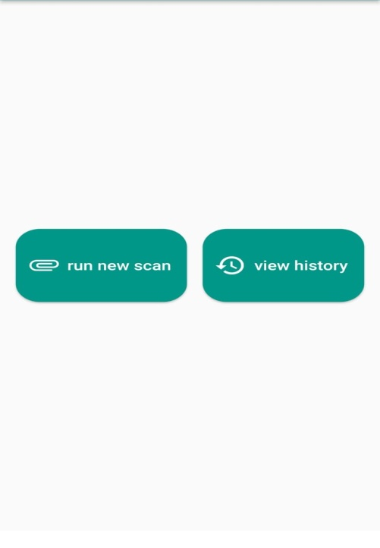

Then the will Application let you put the information of the patient (name, email, phone number, age and if it’s for a clinic or an individual) then the application will show you the results .

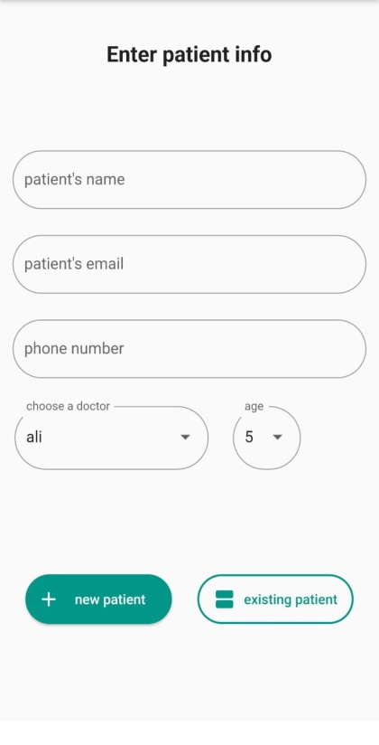 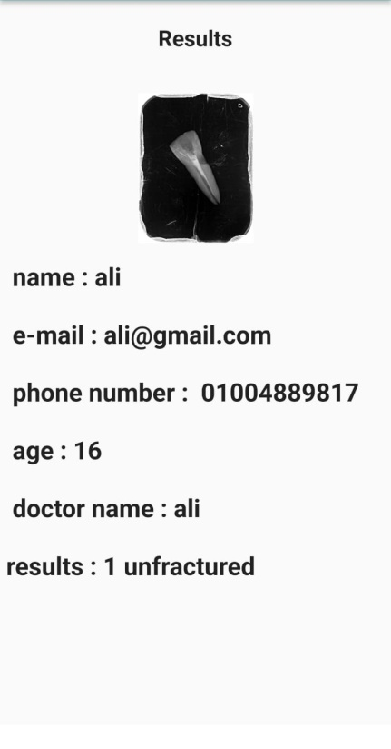

# REFERENCES

1. M. Khazaei et al, "Artificial Intelligence-Based Diagnosis of Dental Fractures on Panoramic Radiographs" . in Journal of Clinical and Diagnostic Research, 2021.

[2] Braly BV, Maxwell EH. Potential for tooth fracture in restorative dentistry. J Prosthet Dent. 1981 Apr;45(4):411-4.

[3] Rakhshan V, Sforza C, Vucinic P, Vitalariu AM, De Menezes M. Advanced Digital Dentistry. Int J Dent. 2018 Dec 26;2018

[4] Park WJ, Park JB. History and application of artificial neural networks in dentistry. Eur J Dent. 2018 Oct-Dec;12(4):594-601

[5] Agrawal P, Nikhade P. Artificial Intelligence in Dentistry: Past, Present, and Future. Cureus. 2022 Jul 28;14(7)

[6] Wang P, Yan XB, Lui DG, Zhang WL, Zhang Y, Ma XC. Detection of dental root fractures by using cone-beam computed tomography. Dentomaxillofac Radiol. 2011 Jul

[7] Khasnis SA, Kidiyoor KH, Patil AB, Kenganal SB. Vertical root fractures and their management. J Conserv Dent. 2014 Mar;17(2)

## 5.2 REFERENCES TO ELECTRONIC SOURCES

The guidelines for citing electronic information as offered below are a modified illustration of the adaptation by the International Standards Organization (ISO) documentation system and the American Psychological Association (APA) style. Three pieces of information are required to complete each reference: 1) protocol or service; 2) location where the item is to be found; and 3) item to be retrieved. It is not necessary to repeat the protocol (i.e., http) in Web addresses after “Available” since that is stated in the URL.

[8] Hung KF, Ai QYH, Leung YY, Yeung AWK. Potential and impact of artificial intelligence algorithms in dento-maxillofacial radiology. Clin Oral Investig. 2022 Sep;26(9)

<https://pubmed.ncbi.nlm.nih.gov/35438326/>

[9] Oguz, R. T., Goksel, B., & Cukur, H. (2021). Deep learning-based detection of dental fractures in cone-beam computed tomography images. International Journal of Computer Assisted Radiology and Surgery, 16(1), 1-12.Papers Presented at Conferences:

[https://link.springer.com/article/10.1186/s12880-021-00618-z#Bib1](https://link.springer.com/article/10.1186/s12880-021-00618-z%23Bib1)

[10] Chen, H., Liu, X., & Zhang, X. (2020). Automatic detection of dental root fractures using deep learning algorithms. Journal of Endodontics, 46(12), 1738-1744.

<https://www.ncbi.nlm.nih.gov/pmc/articles/PMC3520261/>

# APPENDICES[1]

**APPENDIX A: SURVEYS**

Introduction: The purpose of this survey is to gather feedback on an application designed to detect tooth fractures. The application uses artificial intelligence to analyze X-ray images of teeth and identify any signs of fracture or damage. Your participation is voluntary and your responses will remain anonymous. Please answer each question to the best of your ability.

1-Have you ever used an application to detect tooth fractures?

* Yes
* No

2- How easy was the application to use?

* Very easy
* Somewhat easy
* Neutral
* Somewhat difficult
* Very difficult

3- Did the application accurately identify any tooth fractures?

* Yes
* No

4-How confident were you in the accuracy of the application's diagnosis?

* Very confident
* Somewhat confident
* Neutral
* Somewhat unsure
* Very unsure

5-Would you recommend this application to others?

* Yes
* No

6-What improvements would you suggest to make the application more effective or easier to use?

Thank you for your participation! Your feedback will help us improve the design and functionality of the application, and better understand how it can be used to detect and treat toothfractures.

**APPENDIX B: CODE USED FOR DEVELOPMENT**

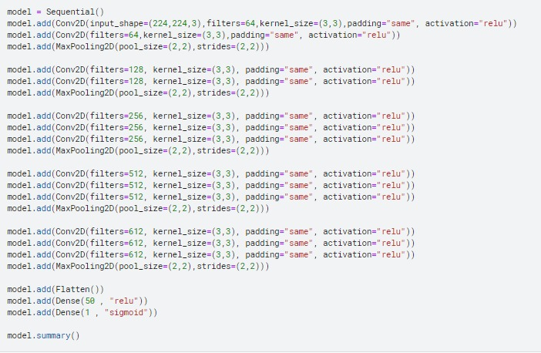

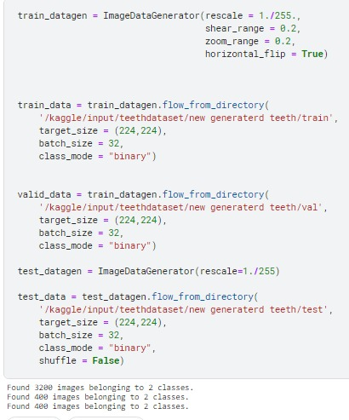

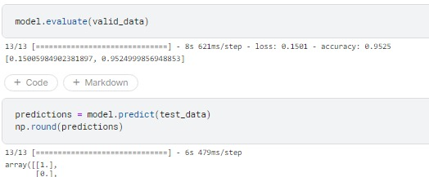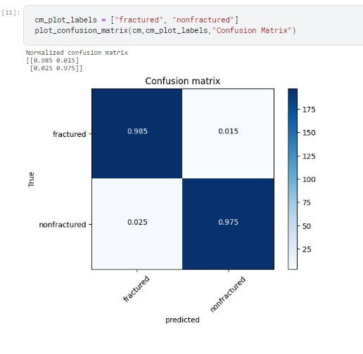



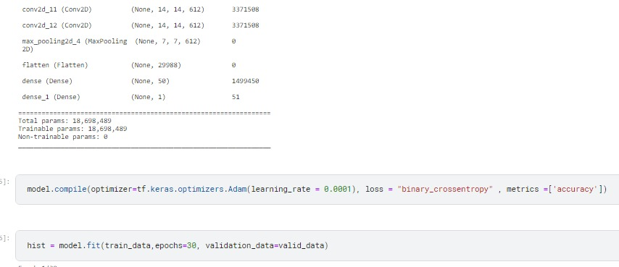

**APPENDIX C: ALGORITHM USED**

* CNN
* Tensorflow library

## APPENDIX D: SAMPLE REPORT

We provide here a report of the development of application power by AI that is going to detect the tooth fracture by uploading the picture of the X-ray and the application is going to detect the tooth fracture. This report outlines the project goals, the methodologies and the results of this project.

1- Project Goals

The primary goal of this project was to develop an AI-powered application that can accurately detect tooth fractures using scanning X-rays. The application was designed to assist dental professionals in diagnosing tooth fractures quickly and accurately.

2- The Methodologies

To develop the application, We collected a large dataset of scanning X-rays of teeth with and without fractures from the hospital of the Misr University for Science and Technology(4000 image of teeth). We used this dataset to train an algorithm to identify patterns in the X-rays that indicate the presence of a fracture.

The trained algorithm was integrated into a user-friendly application that can be used by dentists.

3-The Results

The result of this project is an application that can detect teeth fracture by uploading the X-ray image to the application and can detect the fracture with 95% accuracy.

## المستخلص

Translation is too long to be saved

الأخطاء جزء متأصل في الإنسان ، ويمكن أن تتراوح عواقبها من الحادة إلى التسبب في ألم ومعاناة شديدين للمرضى. لمعالجة هذه المشكلة ، شرعنا في مهمة لمساعدة الأطباء في تحديد الأسنان المكسورة من خلال الاستفادة من قوة الذكاء الاصطناعي . الحالات التي يتم تشخيصها بشكل خاطئ شائعة في طب الأسنان والطب ، وغالبًا ما تُعزى إلى خطأ بشري. كلما تأخر التشخيص ، زادت خطورة الموقف. تشكل كسور الجذور تحديًا خاصًا لأنها تتطلب عادةً الأشعة السينية وخبرة الطبيب للتشخيص الدقيق ، ومع ذلك فإن الأطباء ، كونهم بشرًا ، معرضون للأخطاء. يركز هذا المشروع على تسخير تقنية الذكاء الاصطناعي في طب الأسنان لتعزيز قدرات الأطباء التشخيصية لكسور الجذر. من خلال تطوير تطبيق ، يمكن للأطباء تحليل صور الأشعة السينية لأسنان المرضى ، مما يضمن تشخيصًا أكثر موثوقية ودقة. علاوة على ذلك ، يمكن للمرضى أنفسهم استخدام التطبيق للحصول على رأي ثانٍ ، وبالتالي تأكيد دقة التشخيص الأولي. من خلال دمج الذكاء الاصطناعي في ممارسة طب الأسنان ، نهدف إلى تقليل الأخطاء وتحسين نتائج المرضى. يؤكد هذا البحث على إمكانات الذكاء الاصطناعي كأداة قيمة في مجال الرعاية الصحية ، مما يوفر دقة تشخيصية محسّنة ويمكّن المرضى من المشاركة بنشاط في قرارات الرعاية الصحية الخاصة بهم.

**نظام المعلومات لتطبيق طب الاسنان الرقمي: تطبيق طب الاسنان الرقمي**

مقدم من:

*احمد جمال 89632*

*يوسف محمد محمود 89474*

*يوسف محمد ابراهيم 89503*

*عمار ياسر 89650*

تحت اشراف:

دكتور ريم محمد

م. شرين يوسف

م. محمد عمر

جامعة مصر للعلوم والتكنولوجيا- MUST

كلية الحاسبات وتقنيات الذكاء االصطناعي CAIT-

قسم علوم الحاسب -CS

1. Each appendix is on a separate page.